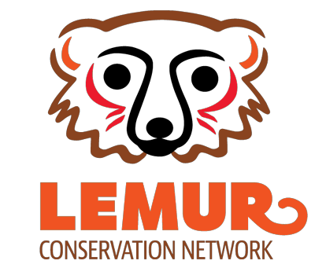

Zoo Application for Website

Name of Zoo

Affiliated Universities/Institutions

Street Address

City State/Province

Zip/Postal Code Country

Phone

Email Website

Social Media Sites

Describe the lemur population at your zoo, and anything unique about your lemur program.

Do you work with organizations in Madagascar on lemur conservation programs? If so, please describe.
Would you be willing to advertise the Lemur Conservation Network to your park visitors, in the form of signage, etc.?
This is not a disqualifier, but we’d love to have you promote us!
Form Completion

Please email your completed form to Corey Romberg at cbromber@asu.edu.

I, hereby confirm that the information I have provided on behalf of my organization is true and correct. By providing this information, I give the Lemur Conservation Network permission to post information about my organization on the Lemur Conservation Network website. I understand that a listing on the website does not guarantee donations to my organization. I also understand that I must inform the Lemur Conservation Network if the mission of the organization or project changes and if the project becomes ineligible for inclusion on the Lemur Conservation Network website. I understand that I
can remove my organization from the Lemur Conservation Network website at any time by emailing Corey Romberg at the email address above.

Name Title Date
Organization

