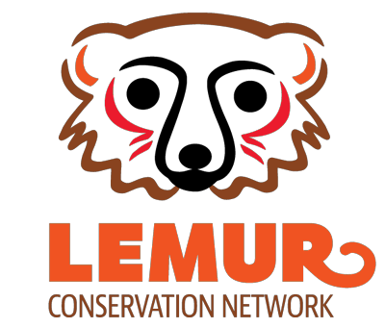

Organization Application for Website

Name of Organization

Street Address

City State/Province

Zip/Postal Code Country

Phone

Email Website

Organization Legal Status
Country where organization is registered  Is your organization tax-deductible in this country? | Yes | No
Organization Type Non-profit For-profit | Government |  | Academic

Other If other, explain:

If you are a non-profit, please provide a copy of your non-profit registration information. If you are affiliated with a non-profit, please provide documentation of that partnership and information regarding the nature of the partnership. All other organizations must provide information about their legal status.
Nature of Work
Does your organization currently undertake work in Madagascar? Yes No

Does your organization currently undertake work related to lemur conservation, environmental protection, or other programs that help conserve lemur populations in Madagascar?
Yes No

Organizations must undertake lemur conservation or environment-related programming in Madagascar.

Location
In what area(s) of Madagascar do you conduct work?
North | Northeast | Northwest
South | Southeast | Southwest
West | East | Central

Mission
Please provide the mission statement of your organization.

Themes
Please check all “themes” that apply to your lemur-related and environmental protection programs, and provide additional details where requested.
Species specific Which species?

Habitat protection Which region, area or park? Captive management
Eco-tourism

Environmental policy
Project Description
Note: You can be as detailed as you like. Keep in mind that the primary audience is potential donors who are interested in your work.

Project Overview: Please describe your project(s) including: area, date of program implementation, budget, objectives, anticipated outcomes, notable successes, and end date (if there is one).

Community Partnerships and Sustainability: Please describe how and if your organization partners with the local community, and how you ensure your programs are sustainable.
Acceptance of Donations
Please describe your current ability to accept online donations from US-based and other remote donors.

For example, does your organization collection donations on your website? Via PayPal? Through a third-party organization? If you are an organization that also has programming for non-lemur or non-environmental initiatives, can you ensure that donations can be directed specifically for lemur and environmental programs?

Form Completion

Please email your completed form to Corey Romberg at cbromber@asu.edu. You must also provide
- documents providing evidence of your registration as, or affiliation with, a nonprofit; 2) a high-quality version of your organization logo (if possible); and 3) a maximum of 5 high-quality images depicting your organization’s lemur-related work in Madagascar (if possible).

I, hereby confirm that the information I have provided on behalf of my organization is true and correct. By providing this information, I give the Lemur Conservation Network permission to post information about my organization on the Lemur Conservation Network website, which is an informational website designed to inform potential donors about different projects that are working on lemur conservation in Madagascar. I understand that a listing on the website does not guarantee donations to my organization. I also understand that I must inform the Lemur Conservation Network if the mission of the organization or project changes and if the project becomes ineligible for inclusion on the Lemur Conservation Network website. I understand that I can remove my organization from the Lemur Conservation Network website at any time by emailing Corey Romberg at the email address above.

Name Title Date
Organization

